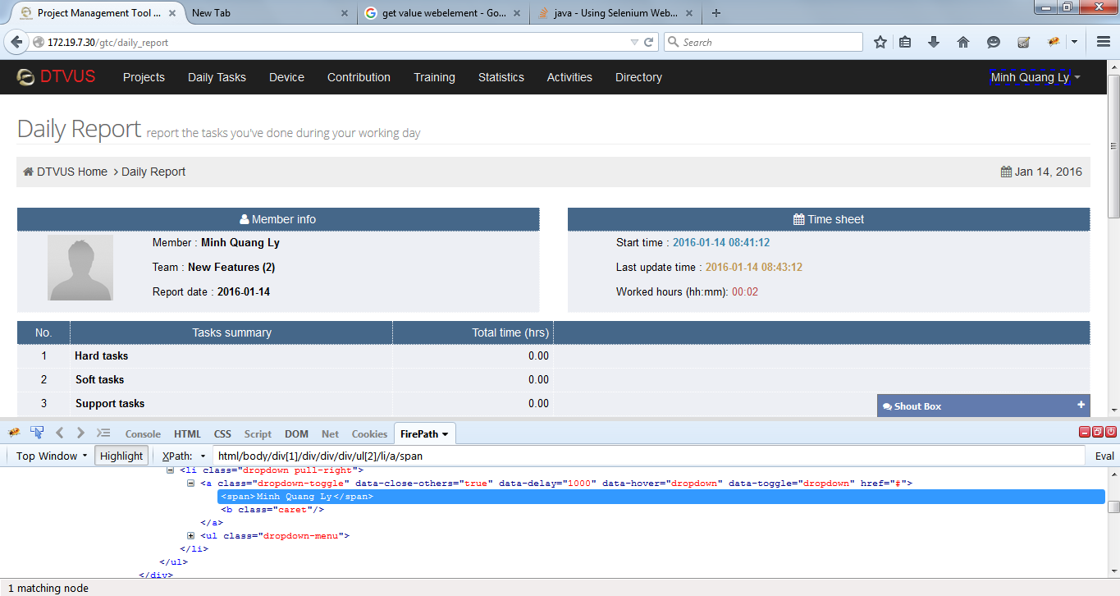

To get value ("Ly Quang Minh") from above Element, we use method getText()
WebElement profileName = firefox.findElement(By.xpath("html/body/div[1]/div/div/div/ul[2]/li/a/span"));
String testValue = profileName.getText()

We need to use getAttribute("value") method to extract data from field which is inputtable, do not use getText() method. In case, field is not inputtable, we use getText() method.

